
Date | 30 September 2026
Team ID | SWTID-2026-9152
Project Name | Import Data using Transform Maps (Spreadsheet)
Team Leader | Muthupramu M
Team Member | Sankaralakshmi A
 | Regina S
 | Thansiya A
Maximum Marks | 5 Marks

Project Title:
Import Data using Transform Maps

3. Project Design Phase

The design phase outlines the architecture of the data flow within the ServiceNow instance:

- Data Source: An external Excel file containing sample employee details.
- Staging Area: The Employee Import table, which temporarily holds raw data loaded from the file.
- Transformation Engine: The Sample Spreadsheet Import Transform Map, acting as the bridge that maps source columns to target fields (using Auto Map Matching) and applies the Coalesce logic on Employee ID.
- Destination: The Employee Test custom table where the finalized records are inserted or updated.
- Visualization: A custom Dashboard named Employee Analytics Dashboards displaying three key widgets:
- Employees by Department (Pie Chart)
- Employees by Location (Bar Chart)
- Employee List Report (List View)

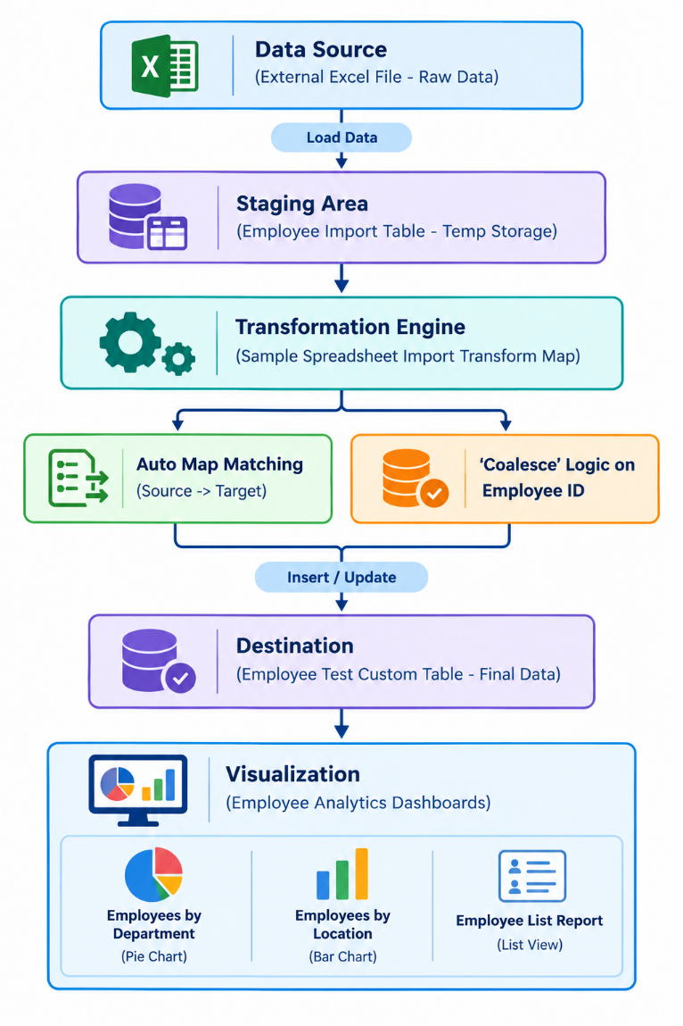

Screenshot:

